**Network Programming for Engineers (ECE 5650)**

**Project 1**

**Team Members Names: Anika Tasnim & Li Lin**

**Source Code(s):**

**Source code for server.py:**

#!/usr/bin/python

# -*- coding: UTF-8 -*-

# File Name：Server.py

# Created: 9/16/2020

# Author: Li Lin & Anika Tasnim

**import** os

**import** sys

**import** socket

**import** threading

**import** tkinter **as** tk

**import** tkinter**.**scrolledtext **as** ScrolledText

**from** datetime **import** datetime

**import** time

**import** struct

**import** re

serverPort **=** 12000

#Create main window

window **=** tk**.**Tk**()**

#Set widnow's title

window**.**title**(**'Server'**)**

#Set window width and height

window**.**geometry**(**'1040x650'**)**

LoggingText **=** ScrolledText**.**ScrolledText**(**window**,** height**=**10**,** width **=** 68**)**

LoggingText**.**place**(**x**=**200**,** y**=**30**,** anchor**=**'nw'**)**

ReceivedText **=** ScrolledText**.**ScrolledText**(**window**,** height**=**33**,** width **=** 68**)**

ReceivedText**.**place**(**x**=**10**,** y**=**200**,** anchor**=**'nw'**)**

ProcessedText **=** ScrolledText**.**ScrolledText**(**window**,** height**=**33**,** width **=** 68**)**

ProcessedText**.**place**(**x**=**520**,** y**=**200**,** anchor**=**'nw'**)**

#Labels

LogLabel **=** tk**.**Label**(**window**,** text**=**'Log'**)**

LogLabel**.**place**(**x**=**200**,** y**=**5**,** anchor**=**'nw'**)**

ReceivedLabel **=** tk**.**Label**(**window**,** text**=**'Received'**)**

ReceivedLabel**.**place**(**x**=**20**,** y**=**175**,** anchor**=**'nw'**)**

ProcessedLabel **=** tk**.**Label**(**window**,** text**=**'Processed'**)**

ProcessedLabel**.**place**(**x**=**530**,** y**=**175**,** anchor**=**'nw'**)**

isConnected **=** **False**

**def** StartServerThread**():**

**global** isConnected

**try:**

**while** **True:**

**if** isConnected **==False:**

#Create socket with IPv4/TCP type

**with** socket**.**socket**(**socket**.**AF_INET**,** socket**.**SOCK_STREAM**)** **as** serversocket**:**

#bind with server address and port

serversocket**.**bind**((**''**,**serverPort**))**

#Start to monitor

serversocket**.**listen**(**1**)**

LoggingText**.**insert**(**'insert'**,** 'Waiting for connection\n'**)**

#wait for client's connection

connection**,**addr **=** serversocket**.**accept**()**

#print(connection, addr)

LoggingText**.**insert**(**'insert'**,** 'connected with {0}:{1}\n'**.**format**(**addr**[**0**],**addr**[**1**]))**

LoggingText**.**insert**(**'insert'**,** 'Waiting for request\n'**)**

isConnected **=** **True**

rcv_thread **=** threading**.**Thread**(**target**=**ReceiveDataThread**,** name **=** 'ReceiveDataThread'**,** args**=(**connection**,**addr**),** daemon**=True)**

**if** **not** rcv_thread**.**is_alive**():**

rcv_thread**.**start**()**

**except** socket**.**error **as** msg**:**

**print(**msg**)**

**else:**

**print(**"Start thread finished"**)**

**def** UpdateLoggingToEnd**():**

**while** **True:**

LoggingText**.**see**(**'end'**)**

time**.**sleep**(**0.5**)**

**def** StartServer**():**

start_thread **=** threading**.**Thread**(**target**=**StartServerThread**,** name **=** 'StartServerThread'**,** daemon**=True)**

**if** **not** start_thread**.**is_alive**():**

start_thread**.**start**()**

**print(**'Start threading started'**)**

#StartButton.config(text='Stop')

**else:**

LoggingText**.**insert**(**'insert'**,** 'server is already started\n'**)**

UpdateLogging_thread **=** threading**.**Thread**(**target**=**UpdateLoggingToEnd**,** name **=** 'UpdateLoggingthread'**,** daemon**=True)**

**if** **not** UpdateLogging_thread**.**is_alive**():**

UpdateLogging_thread**.**start**()**

StartButton **=** tk**.**Button**(**window**,** text**=**'Start'**,** font**=(**'Arial'**,**12**),** width**=**14**,** height**=**4**,** command **=** StartServer**)**

StartButton**.**place**(**x**=**30**,** y**=**30**,** anchor**=**'nw'**)**

#reqtype = ('SEARCH','REPLACE','REVERSE')

**def** ReceiveDataThread**(**connection**,**address**):**

**global** isConnected

request **=** ''

search_word **=** ''

replace_word **=** ''

**with** connection**:**

status **=** 'WAIT_FOR_REQUEST'

**while** isConnected**:**

**print(**'waiting receive data'**)**

**if(**status **==** 'WAIT_FOR_REQUEST'**):**

#Receive message from client

message **=** connection**.**recv**(**1024**)**

**if** **not** message**:**

isConnected **=** **False**

**break**

message **=** message**.**decode**()**

**print(**message**)**

**if** message**.**find**(**'SEARCH+'**)** **!=** **-**1**:**

LoggingText**.**insert**(**'insert'**,** 'Search request received and accepted\n'**)**

request **=** 'SEARCH'

search_word **=** message**.**split**(**'+'**,**1**)[**1**]**

**if** search_word **==** ''**:**

message **=** 'No search word defined!'

#keep current status

**else:**

message **=** 'Search request accepted'

status **=** 'WAIT_FOR_FILE_INFO'

connection**.**send**(**message**.**encode**())**

**elif** message**.**find**(**'REPLACE+'**)** **!=** **-**1**:**

LoggingText**.**insert**(**'insert'**,** 'Replace request received and accepted\n'**)**

request **=** 'REPLACE'

msg_list **=** message**.**split**(**'+'**,**2**)**

search_word **=** msg_list**[**1**]**

replace_word **=** msg_list**[**2**]**

**if** search_word **==** ''**:**

message **=** 'No search word defined!'

#keep current status

**else:**

message **=** 'Replace request accepted'

status **=** 'WAIT_FOR_FILE_INFO'

connection**.**send**(**message**.**encode**())**

**elif** message **==**'REVERSE'**:**

LoggingText**.**insert**(**'insert'**,** 'reverse request received and accepted\n'**)**

request **=** 'REVERSE'

message **=** 'Reverse request accepted'

connection**.**send**(**message**.**encode**())**

status **=** 'WAIT_FOR_FILE_INFO'

**elif** message **==** 'EXIT'**:**

LoggingText**.**insert**(**'insert'**,** 'Exit request received\n'**)**

connection**.**close**()**

isConnected **=** **False**

**else:**

message **=**'unrecognized request!'

**elif** **(**status **==** 'WAIT_FOR_FILE_INFO'**):**

fileinfo_size **=** struct**.**calcsize**(**'128sQ'**)**

fileinfo_data **=** connection**.**recv**(**fileinfo_size**)**

**if** **not** fileinfo_data**:**

isConnected **=** **False**

**break**

#Receive file name and size info

filename**,**filesize **=** struct**.**unpack**(**'128sQ'**,**fileinfo_data**)**

rcv_file_name **=** filename**.**decode**(**'utf-8'**).**strip**(**'\x00'**)**

LoggingText**.**insert**(**'insert'**,** 'Head info received\n'**)**

#Receive the data of file

received_size **=** 0

all_data_str **=** ''

**with** open**(**rcv_file_name**,** 'wb'**)** **as** rcv_file_handle**:**

#Clear the content firstly

ReceivedText**.**delete**(**1.0**,**'end'**)**

**while** **not** **(**received_size **==** filesize**):**

**if(**filesize **-** received_size **>** 1024**):**

data **=** connection**.**recv**(**1024**)**

**if** **not** data**:**

isConnected **=** **False**

**break**

received_size **+=** len**(**data**)**

**else:**

data **=** connection**.**recv**(**filesize **-** received_size**)**

received_size **=** filesize

rcv_file_handle**.**write**(**data**)**

ReceivedText**.**insert**(**'insert'**,**data**.**decode**())**

all_data_str **=** all_data_str **+** data**.**decode**()**

**if** isConnected **==** **False:**

LoggingText**.**insert**(**'insert'**,** '{0} file transfer failed\n'**.**format**(**rcv_file_name**))**

**else:**

LoggingText**.**insert**(**'insert'**,** 'Received all data of {0}\n'**.**format**(**rcv_file_name**))**

ProcessedText**.**delete**(**1.0**,**'end'**)**

#Process the file according to request

**if** request **==** 'SEARCH'**:**

#Search

count **=** all_data_str**.**count**(**search_word**)**

message **=** 'There are {0} words "{1}" found in {2}.'**.**format**(**count**,**search_word**,**rcv_file_name**)**

ProcessedText**.**insert**(**'insert'**,**'There are {0} words "{1}" found in {2}'**.**format**(**count**,**search_word**,**rcv_file_name**))**

connection**.**send**(**message**.**encode**())**

status **=** 'WAIT_FOR_REQUEST'

LoggingText**.**insert**(**'insert'**,** 'Search result sent\n'**)**

**elif** request **==** 'REPLACE'**:**

#Replace

replaced_data **=** all_data_str**.**replace**(**search_word**,**replace_word**)**

replaced_file_name **=** os**.**path**.**join**(**'./'**,** 'Replaced_' **+** rcv_file_name**)**

ProcessedText**.**insert**(**'insert'**,**replaced_data**)**

#Store local file

**with** open**(**replaced_file_name**,** 'wb'**)** **as** new_file_handle**:**

new_file_handle**.**write**(**replaced_data**.**encode**())**

**with** open**(**replaced_file_name**,** 'rb'**)** **as** new_file_handle**:**

#Send file info to client

fileinfo_size **=** struct**.**calcsize**(**'128sQ'**)** #file name lentgh = 128 bytes; filesize = 8bytes

#define file head info, including name and size

fhead **=** struct**.**pack**(**'128sQ'**,** bytes**(**replaced_file_name**.**encode**(**'utf-8'**)),** len**(**replaced_data**.**encode**(**'utf-8'**)))**

connection**.**send**(**fhead**)**

LoggingText**.**insert**(**'insert'**,** 'Replaced file header info sent\n'**)**

#send file data to client

**while** **True:**

send_data **=** new_file_handle**.**read**(**1024**)**

**print(**send_data**.**decode**())**

**if** **not** send_data**:**

LoggingText**.**insert**(**'insert'**,** 'Replaced file send over...\n'**)**

**break**

connection**.**send**(**send_data**)**

**print(**data**.**decode**())**

status **=** 'WAIT_FOR_REQUEST'

**elif** request **==** 'REVERSE'**:**

#Reverse

data_str_list **=** all_data_str**.**split**()**

reversed_data **=** ' '**.**join**(**reversed**(**data_str_list**))**

ProcessedText**.**insert**(**'insert'**,**reversed_data**)**

reversed_file_name **=** os**.**path**.**join**(**'./'**,** 'Replaced_' **+** rcv_file_name**)**

#Store local file

**with** open**(**reversed_file_name**,** 'wb'**)** **as** new_file_handle**:**

new_file_handle**.**write**(**reversed_data**.**encode**())**

**with** open**(**reversed_file_name**,** 'rb'**)** **as** new_file_handle**:**

#Send file info to client

fileinfo_size **=** struct**.**calcsize**(**'128sQ'**)** #file name lentgh = 128 bytes; filesize = 8bytes

#define file head info, including name and size

fhead **=** struct**.**pack**(**'128sQ'**,** bytes**(**reversed_file_name**.**encode**(**'utf-8'**)),** len**(**reversed_data**.**encode**(**'utf-8'**)))**

connection**.**send**(**fhead**)**

LoggingText**.**insert**(**'insert'**,** 'Reversed file header info sent\n'**)**

#send file data to client

**while** **True:**

send_data **=** new_file_handle**.**read**(**1024**)**

**if** **not** send_data**:**

LoggingText**.**insert**(**'insert'**,** 'Reversed file send over...\n'**)**

**break**

connection**.**send**(**send_data**)**

status **=** 'WAIT_FOR_REQUEST'

**else:**

message **=** 'unrecognized request!'

status **=** 'WAIT_FOR_REQUEST'

**else:**

**print(**'Server is in unknown status'**)**

status **=** 'WAIT_FOR_REQUEST'

LoggingText**.**insert**(**'insert'**,** 'Connection closed\n'**)**

window**.**mainloop**()**

**Source code for client.py:**

#!/usr/bin/python

# -*- coding: UTF-8 -*-

# File Name：Client.py

# Created: 9/16/2020

# Author: Li Lin & Anika Tasnim

**import** socket

**import** tkinter **as** tk

**from** tkinter **import** filedialog

**from** tkinter **import** ttk

**import** tkinter**.**scrolledtext **as** ScrolledText

**import** os

**import** sys

**import** struct

**import** threading

**import** win32api

**from** datetime **import** datetime

**import** time

serverName **=** 'localhost' #'192.168.0.15'

serverPort **=** 12000

CurrentDirectory **=** os**.**getcwd**()**

#Create main GUI window

window **=** tk**.**Tk**()**

#Set widnow's title

window**.**title**(**'Client'**)**

#Set window width and height

window**.**geometry**(**'1305x650'**)**

isConnected **=** **False**

#Create a Entry

SearchWordVar **=** tk**.**StringVar**()**

SearchWordEntry **=** tk**.**Entry**(**window**,** show**=None,** font**=(**'Arial'**,**14**),** width **=** 12**,** textvariable**=**SearchWordVar**)**

SearchWordEntry**.**place**(**x**=**150**,** y**=**80**,** anchor**=**'nw'**)**

SearchWordVar**.**set**(**'Mobile'**)**

ReplaceWordVar **=** tk**.**StringVar**()**

ReplaceWordEntry **=** tk**.**Entry**(**window**,** show**=None,** font**=(**'Arial'**,**14**),** width **=** 12**,** textvariable**=**ReplaceWordVar**)**

ReplaceWordEntry**.**place**(**x**=**300**,** y**=**80**,** anchor**=**'nw'**)**

ReplaceWordVar**.**set**(**'iPhone'**)**

SourceFilePathVar **=** tk**.**StringVar**()**

SourceFilePathEntry **=** tk**.**Entry**(**window**,** show**=None,** font**=(**'Arial'**,**14**),** width **=** 44**,** textvariable**=**SourceFilePathVar**)**

SourceFilePathEntry**.**place**(**x**=**10**,** y**=**160**,** anchor**=**'nw'**)**

SourceFilePathVar**.**set**(**'C:/GitHubProject/NetworkProgramming/Project1/Mobile IP wiki.txt'**)**

SaveFileNameVar **=** tk**.**StringVar**()**

SaveFileNameEntry **=** tk**.**Entry**(**window**,** show**=None,** font**=(**'Arial'**,**14**),** width **=** 15**,** textvariable**=**SaveFileNameVar**)**

SaveFileNameEntry**.**place**(**x**=**1000**,** y**=**194**,** anchor**=**'nw'**)**

SaveFileNameVar**.**set**(**'output.txt'**)**

#Label

LogLabel **=** tk**.**Label**(**window**,** text**=**'Log'**)**

LogLabel**.**place**(**x**=**650**,** y**=**10**,** anchor**=**'nw'**)**

SourceLabel **=** tk**.**Label**(**window**,** text**=**'Source file'**)**

SourceLabel**.**place**(**x**=**20**,** y**=**210**,** anchor**=**'nw'**)**

ReceivedLabel **=** tk**.**Label**(**window**,** text**=**'Received from server'**)**

ReceivedLabel**.**place**(**x**=**670**,** y**=**210**,** anchor**=**'nw'**)**

SearchLabel **=** tk**.**Label**(**window**,** text**=**'Search word'**)**

SearchLabel**.**place**(**x**=**150**,** y**=**59**,** anchor**=**'nw'**)**

ReplaceLabel **=** tk**.**Label**(**window**,** text**=**'Replace word'**)**

ReplaceLabel**.**place**(**x**=**300**,** y**=**59**,** anchor**=**'nw'**)**

SaveLabel **=** tk**.**Label**(**window**,** text**=**'Save file name'**)**

SaveLabel**.**place**(**x**=**1000**,** y**=**173**,** anchor**=**'nw'**)**

#Create Text

SourceFileText **=** ScrolledText**.**ScrolledText**(**window**,** height**=**30**,** width **=** 88**)**

SourceFileText**.**place**(**x**=**10**,** y**=**230**,** anchor**=**'nw'**)**

**if** os**.**path**.**isfile**(**SourceFilePathVar**.**get**()):**

**with** open**(**SourceFilePathVar**.**get**(),**'rb'**)** **as** reader**:**

SourceFileText**.**delete**(**1.0**,**'end'**)**

text **=** reader**.**read**()**

SourceFileText**.**insert**(**'insert'**,**text**)**

ProcessedFileText **=** ScrolledText**.**ScrolledText**(**window**,** height**=**30**,** width **=** 90**)**

ProcessedFileText**.**place**(**x**=**650**,** y**=**230**,** anchor**=**'nw'**)**

LoggingText **=** ScrolledText**.**ScrolledText**(**window**,** height**=**10**,** width **=** 90**)**

LoggingText**.**place**(**x**=**650**,** y**=**40**,** anchor**=**'nw'**)**

#update text to show end content

**def** UpdateLoggingToEnd**():**

**while** **True:**

LoggingText**.**see**(**'end'**)**

time**.**sleep**(**0.5**)**

UpdateLogging_thread **=** threading**.**Thread**(**target**=**UpdateLoggingToEnd**,** name **=** 'UpdateLoggingthread'**,** daemon**=True)**

**if** **not** UpdateLogging_thread**.**is_alive**():**

UpdateLogging_thread**.**start**()**

#Socket created

clientSocket **=** socket**.**socket**(**socket**.**AF_INET**,** socket**.**SOCK_STREAM**)**

#Create buttons

**def** ConnectServer**():**

**global** isConnected

**if** **not** isConnected**:**

**try:**

#Setup connection with server

clientSocket**.**connect**((**serverName**,**serverPort**))**

**except** socket**.**error **as** msg**:**

now **=** str**(**datetime**.**now**())[:-**7**]**

LoggingText**.**insert**(**'insert'**,**'{0}: Server Connected failed({1})\n'**.**format**(**now**,**msg**))**

**else:**

isConnected **=** **True**

now **=** str**(**datetime**.**now**())[:-**7**]**

LoggingText**.**insert**(**'insert'**,**'{0}: Server Connected\n'**.**format**(**now**))**

**else:**

LoggingText**.**insert**(**'insert'**,**'Server already Connected )\n'**)**

ConnectButton **=** tk**.**Button**(**window**,** text**=**'Connect'**,** font**=(**'Arial'**,**12**),** width**=**10**,** height**=**2**,** command **=** ConnectServer**)**

ConnectButton**.**place**(**x**=**10**,** y**=**10**,** anchor**=**'nw'**)**

**def** ExitThread**():**

**global** isConnected

**if** isConnected**:**

request **=** 'EXIT'

clientSocket**.**send**(**request**.**encode**())**

LoggingText**.**insert**(**'insert'**,**'Exit request sent to server\n'**)**

clientSocket**.**close**()**

**else:**

LoggingText**.**insert**(**'insert'**,**'No connection\n'**)**

window**.**destroy**()**

**def** ExitProcess**():**

exit_thread **=** threading**.**Thread**(**target**=**ExitThread**,** name**=**'ExitThread'**)**

exit_thread**.**setDaemon**(True)**

exit_thread**.**start**()**

**print(**'Exit threading started'**)**

ExitButton **=** tk**.**Button**(**window**,** text**=**'Exit'**,** font**=(**'Arial'**,**12**),** width**=**10**,** height**=**2**,** command **=** ExitProcess**)**

ExitButton**.**place**(**x**=**10**,** y**=**70**,** anchor**=**'nw'**)**

**def** SearchThread**():**

**global** isConnected

**if** isConnected**:**

#1.Send request to server

search_word **=** SearchWordVar**.**get**()**

request **=** 'SEARCH+' **+** search_word

**try:**

clientSocket**.**send**(**request**.**encode**())**

**except** socket**.**error **as** msg**:**

now **=** str**(**datetime**.**now**())[:-**7**]**

LoggingText**.**insert**(**'insert'**,**'{0}: Server Connected failed({1})\n'**.**format**(**now**,**msg**))**

isConnected **=** **False**

**else:**

LoggingText**.**insert**(**'insert'**,**'Search request sent with search word "{0}"\n'**.**format**(**search_word**))**

#Receive message from server

response **=** clientSocket**.**recv**(**1024**)**

**if** response**:**

LoggingText**.**insert**(**'insert'**,** 'Response from server: {0} \n'**.**format**(**response**.**decode**(**'utf-8'**)))**

**if** response**.**decode**()** **==** 'Search request accepted'**:**

filepath **=** SourceFilePathVar**.**get**()**

**if** os**.**path**.**isfile**(**filepath**):**

#2. Send file info to server

fileinfo_size **=** struct**.**calcsize**(**'128sQ'**)** #file name lentgh = 128 bytes; filesize = 8bytes

#define file head info, including name and size

fhead **=** struct**.**pack**(**'128sQ'**,** bytes**(**os**.**path**.**basename**(**filepath**).**encode**(**'utf-8'**)),**

os**.**stat**(**filepath**).**st_size**)**

clientSocket**.**send**(**fhead**)**

LoggingText**.**insert**(**'insert'**,** 'File header sent\n'**)**

#3. Send data to server

**with** open**(**filepath**,** 'rb'**)** **as** fp**:**

**while** 1**:**

data **=** fp**.**read**(**1024**)**

**if** **not** data**:**

LoggingText**.**insert**(**'insert'**,** 'file send over...\n'**)**

**break**

clientSocket**.**send**(**data**)**

#4. Receive the search result

response **=** clientSocket**.**recv**(**1024**)**

**if** response**:**

#5. Display the search result

LoggingText**.**insert**(**'insert'**,** 'Search result received\n'**)**

ProcessedFileText**.**delete**(**1.0**,**'end'**)**

ProcessedFileText**.**insert**(**'insert'**,**response**.**decode**())**

**else:**

isConnected **=** **False**

LoggingText**.**insert**(**'insert'**,** 'Server connection closed! Please check if server is still running\n'**)**

**else:**

LoggingText**.**insert**(**'insert'**,**'The file path is not valid'**)**

**else:**

isConnected **=** **False**

LoggingText**.**insert**(**'insert'**,** 'Server connection closed! Please check if server is still running\n'**)**

**else:**

LoggingText**.**insert**(**'insert'**,** 'No connection! Please connect firstly\n'**)**

**def** ReplaceThread**():**

**global** isConnected

**if** isConnected**:**

#1.Send request to server

search_word **=** SearchWordVar**.**get**()**

replace_word **=** ReplaceWordVar**.**get**()**

request **=** 'REPLACE+' **+** search_word **+**'+' **+** replace_word

**try:**

clientSocket**.**send**(**request**.**encode**())**

**except** socket**.**error **as** msg**:**

now **=** str**(**datetime**.**now**())[:-**7**]**

LoggingText**.**insert**(**'insert'**,**'{0}: Server Connected failed({1})\n'**.**format**(**now**,**msg**))**

isConnected **=** **False**

**else:**

LoggingText**.**insert**(**'insert'**,**'Replace request sent with search word "{0}" and replace word "{1}"\n'**.**format**(**search_word**,**replace_word**))**

#Receive message from server

response **=** clientSocket**.**recv**(**1024**)**

**if** response**:**

LoggingText**.**insert**(**'insert'**,** 'Response from server: {0} \n'**.**format**(**response**.**decode**(**'utf-8'**)))**

**if** response**.**decode**()** **==** 'Replace request accepted'**:**

filepath **=** SourceFilePathVar**.**get**()**

**if** os**.**path**.**isfile**(**filepath**):**

#2. Send file info to server

fileinfo_size **=** struct**.**calcsize**(**'128sQ'**)** #file name lentgh = 128 bytes; filesize = 8bytes

#define file head info, including name and size

fhead **=** struct**.**pack**(**'128sQ'**,** bytes**(**os**.**path**.**basename**(**filepath**).**encode**(**'utf-8'**)),**

os**.**stat**(**filepath**).**st_size**)**

clientSocket**.**send**(**fhead**)**

LoggingText**.**insert**(**'insert'**,** 'File header sent\n'**)**

#3. Send data to server

**with** open**(**filepath**,** 'rb'**)** **as** fp**:**

**while** 1**:**

data **=** fp**.**read**(**1024**)**

**if** **not** data**:**

LoggingText**.**insert**(**'insert'**,** 'file send over...\n'**)**

**break**

clientSocket**.**send**(**data**)**

#4. Receive the replace result

fileinfo_size **=** struct**.**calcsize**(**'128sQ'**)**

fileinfo_data **=** clientSocket**.**recv**(**fileinfo_size**)**

**if** fileinfo_data**:**

filename**,**filesize **=** struct**.**unpack**(**'128sQ'**,**fileinfo_data**)**

rcv_file_name **=** filename**.**decode**(**'utf-8'**).**strip**(**'\x00'**)**

LoggingText**.**insert**(**'insert'**,** '{0} header info is received and size is {1} bytes\n'**.**format**(**rcv_file_name**,**filesize**))**

received_size **=** 0

received_data **=** ''

**while** **not** **(**received_size **==** filesize**):**

**if(**filesize **-** received_size **>** 1024**):**

data **=** clientSocket**.**recv**(**1024**)**

**if** data**:**

received_size **+=** len**(**data**)**

**else:**

isConnected **=** **False**

**break**

**else:**

data **=** clientSocket**.**recv**(**filesize **-** received_size**)**

**if** data**:**

received_size **=** filesize

**else:**

isConnected **=** **False**

**break**

received_data **=** received_data **+** data**.**decode**()**

**if** isConnected**:**

LoggingText**.**insert**(**'insert'**,** 'Replaced file {0} is received\n'**.**format**(**rcv_file_name**))**

#5. Display the replaced result

ProcessedFileText**.**delete**(**1.0**,**'end'**)**

ProcessedFileText**.**insert**(**'insert'**,** received_data**)**

**else:**

LoggingText**.**insert**(**'insert'**,** 'Server connection closed! Please check if server is still running\n'**)**

**else:**

LoggingText**.**insert**(**'insert'**,** 'The file path is not valid\n'**)**

**else:**

isConnected **=** **False**

LoggingText**.**insert**(**'insert'**,** 'Server connection closed! Please check if server is still running\n'**)**

**else:**

LoggingText**.**insert**(**'insert'**,** 'No connection! Please connect firstly\n'**)**

**def** ReverseThread**():**

**global** isConnected

**if** isConnected**:**

#1.Send request to server

request **=** 'REVERSE'

**try:**

clientSocket**.**send**(**request**.**encode**())**

**except** socket**.**error **as** msg**:**

now **=** str**(**datetime**.**now**())[:-**7**]**

LoggingText**.**insert**(**'insert'**,**'{0}: Server Connected failed({1})\n'**.**format**(**now**,**msg**))**

isConnected **=** **False**

**else:**

LoggingText**.**insert**(**'insert'**,**'Reverse request sent\n'**)**

#Receive message from server

response **=** clientSocket**.**recv**(**1024**)**

**if** response**:**

LoggingText**.**insert**(**'insert'**,** 'Response from server: {0} \n'**.**format**(**response**.**decode**(**'utf-8'**)))**

**if** response**.**decode**()** **==** 'Reverse request accepted'**:**

filepath **=** SourceFilePathVar**.**get**()**

**if** os**.**path**.**isfile**(**filepath**):**

#2. Send file info to server

fileinfo_size **=** struct**.**calcsize**(**'128sQ'**)** #file name lentgh = 128 bytes; filesize = 8bytes

#define file head info, including name and size

fhead **=** struct**.**pack**(**'128sQ'**,** bytes**(**os**.**path**.**basename**(**filepath**).**encode**(**'utf-8'**)),**

os**.**stat**(**filepath**).**st_size**)**

clientSocket**.**send**(**fhead**)**

LoggingText**.**insert**(**'insert'**,** 'File header sent\n'**)**

#3. Send data to server

**with** open**(**filepath**,** 'rb'**)** **as** fp**:**

**while** 1**:**

data **=** fp**.**read**(**1024**)**

**if** **not** data**:**

LoggingText**.**insert**(**'insert'**,** 'file send over...\n'**)**

**break**

clientSocket**.**send**(**data**)**

#4. Receive the reversed result

fileinfo_size **=** struct**.**calcsize**(**'128sQ'**)**

fileinfo_data **=** clientSocket**.**recv**(**fileinfo_size**)**

**if** fileinfo_data**:**

filename**,**filesize **=** struct**.**unpack**(**'128sQ'**,**fileinfo_data**)**

LoggingText**.**insert**(**'insert'**,** 'file header info is received\n'**)**

received_size **=** 0

received_data **=** ''

**while** **not** **(**received_size **==** filesize**):**

**if(**filesize **-** received_size **>** 1024**):**

data **=** clientSocket**.**recv**(**1024**)**

**if** data**:**

received_size **+=** len**(**data**)**

**else:**

isConnected **=** **False**

**break**

**else:**

data **=** clientSocket**.**recv**(**filesize **-** received_size**)**

**if** data**:**

received_size **=** filesize

**else:**

isConnected **=** **False**

**break**

received_data **=** received_data **+** data**.**decode**()**

**if** isConnected**:**

LoggingText**.**insert**(**'insert'**,** 'Reversed file is received\n'**)**

#5. Display the replaced result

ProcessedFileText**.**delete**(**1.0**,**'end'**)**

ProcessedFileText**.**insert**(**'insert'**,** received_data**)**

**else:**

LoggingText**.**insert**(**'insert'**,** 'No connection! Please connect firstly\n'**)**

**else:**

LoggingText**.**insert**(**'insert'**,**'The file path is not valid'**)**

**else:**

isConnected **=** **False**

LoggingText**.**insert**(**'insert'**,** 'No connection! Please connect firstly\n'**)**

**else:**

LoggingText**.**insert**(**'insert'**,** 'No connection! Please connect firstly\n'**)**

**def** SearchWordFromServer**():**

search_thread **=** threading**.**Thread**(**target**=**SearchThread**,** name**=**'SearchThread'**)**

search_thread**.**setDaemon**(True)**

search_thread**.**start**()**

**print(**'Search threading started'**)**

SearchButton **=** tk**.**Button**(**window**,** text**=**'Search'**,** font**=(**'Arial'**,**12**),** width**=**14**,** height**=**2**,** command **=** SearchWordFromServer**)**

SearchButton**.**place**(**x**=**150**,** y**=**5**,** anchor**=**'nw'**)**

**def** ReplaceWordByServer**():**

replace_thread **=** threading**.**Thread**(**target**=**ReplaceThread**,** name**=**'replace_thread'**)**

replace_thread**.**setDaemon**(True)**

replace_thread**.**start**()**

**print(**'Replace threading started'**)**

ReplaceButton **=** tk**.**Button**(**window**,** text**=**'Replace'**,** font**=(**'Arial'**,**12**),** width**=**14**,** height**=**2**,** command **=** ReplaceWordByServer**)**

ReplaceButton**.**place**(**x**=**300**,** y**=**5**,** anchor**=**'nw'**)**

**def** ReverseWordByServer**():**

reverse_thread **=** threading**.**Thread**(**target**=**ReverseThread**,** name**=**'reverse_thread'**)**

reverse_thread**.**setDaemon**(True)**

reverse_thread**.**start**()**

**print(**'Reverse threading started'**)**

ReverseButton **=** tk**.**Button**(**window**,** text**=**'Reverse'**,** font**=(**'Arial'**,**12**),** width**=**14**,** height**=**2**,** command **=** ReverseWordByServer**)**

ReverseButton**.**place**(**x**=**450**,** y**=**5**,** anchor**=**'nw'**)**

**def** SelectFile**():**

SourceFilePath **=** filedialog**.**askopenfilename**(**title**=**'Select source file'**,** filetypes**=[(**"Text files"**,** "*.txt"**),** **(**"all files"**,** "*.*"**)])**

SourceFilePathEntry**.**delete**(**0**,**tk**.**END**)**

SourceFilePathEntry**.**insert**(**0**,**SourceFilePath**)**

**with** open**(**SourceFilePathVar**.**get**(),**'rb'**)** **as** reader**:**

SourceFileText**.**delete**(**1.0**,**'end'**)**

text **=** reader**.**read**()**

SourceFileText**.**insert**(**'insert'**,**text**)**

SelectButton **=** tk**.**Button**(**window**,** text**=**'Source path...'**,** font**=(**'Arial'**,**12**),** width**=**12**,** height**=**1**,** command **=** SelectFile**)**

SelectButton**.**place**(**x**=**510**,** y**=**157**,** anchor**=**'nw'**)**

#callback function for Save button

**def** SaveFile**():**

filename **=** SaveFileNameVar**.**get**()**

filepath **=** os**.**path**.**join**(**CurrentDirectory**,** filename**)**

**print(**filepath**)**

**with** open**(**filepath**,** 'w'**)** **as** fp**:**

file_data **=** ProcessedFileText**.**get**(**1.0**,**'end'**)**

fp**.**write**(**file_data**)**

fp**.**close**()**

LoggingText**.**insert**(**'end'**,** 'File {0} saved under {1}\n'**.**format**(**filename**,**CurrentDirectory**))**

#Create Save button

SaveButton **=** tk**.**Button**(**window**,** text**=**'Save'**,** font**=(**'Arial'**,**12**),** width**=**10**,** height**=**1**,** command **=** SaveFile**)**

SaveButton**.**place**(**x**=**1175**,** y**=**190**,** anchor**=**'nw'**)**

window**.**mainloop**()**

clientSocket**.**close**()**

**Overview of the tools:**

1. Server program GUI overview.

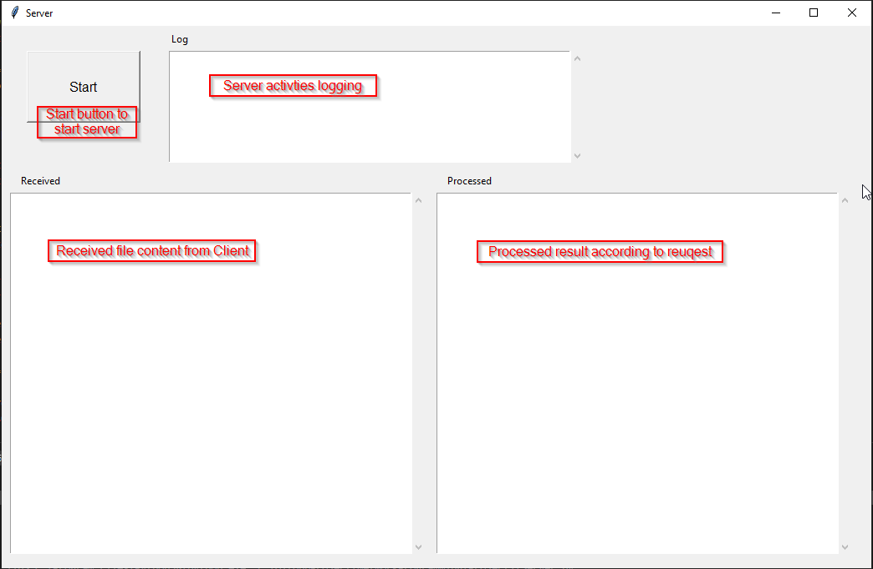

1. Client program GUI overview.

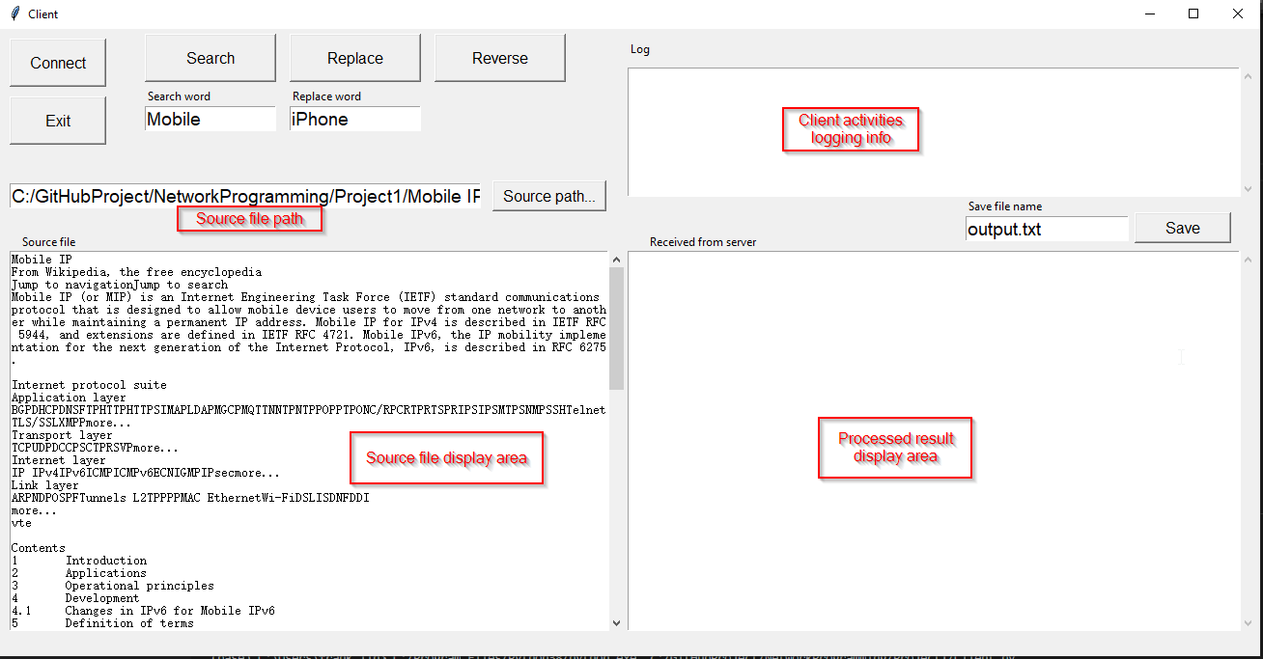

**Testing Procedure, including Description of Inputs**

1. Start Server program, and click on “Start” button.
   1. Server log info should show “Waiting for connection”
2. Start Client program, and click on “Connect” button.
   1. Client log info should show “Server Connected
   2. Server log info should show which client connected and from which port.
   3. Server should wait for a client’s request.
3. In the Client program, do below steps for each function:
   1. **Searching function**:
      1. Click on “Source path…” button to select the file you want to process, the file content shall be displayed in “Source file display area”
      2. Enter the searching word in “Searching word” entry area
      3. Click on button “Search”
      4. Check the result on “Processed result display area” of both Client and Server, they are should be same.
      5. Check on Server program window, the received file content should be same as the Client’s source file.
      6. Check log info of both Client and Server. They should show detail communication steps of search function.
   2. **Replacing function**:
      1. Click on “Source path…” button to select the file you want to process.(skip this step if you want to keep processing previous file loaded)
      2. Enter the searching word in “Searching word” entry area
      3. Enter the replacing word in “Replacing word” entry area
      4. Click on button “Replace”
      5. Check on Server program window, the Received file content should be same as the Client’s source file
      6. Check the Received from server area which should be same as Server Processed area.
      7. Enter the file name in “Save file name” area, Click on “Save” button to save the file.
      8. Check if the file is saved under the location same as Client program.
      9. Check log info of both Client and Server. They should show detail communication steps of Replace function.
   3. **Reverse function**:
      1. Click on “Source path…” button to select the file you want to process.(Skip this step if you want to keep processing previous file loaded)
      2. Click on button “Reverse”
      3. In Client window, Check the result on “Received from server” area which should be same as server’s Processed area content.
      4. Check on Server program window, the Received file content should be same as the Client’s source file.
      5. Enter the file name in “Save file name” area, Click on “Save” button to save the file.
      6. Check if the file is saved under the location same as Client program.
      7. Check log info of both Client and Server. They should show detail communication steps of Replace function.
   4. **Display function**:
      1. Display function is already shown in above steps
      2. After select the source file via “Source path…”, the source file content shall be displayed in below display area automatically.
      3. The received the result shall be displayed in “Processed result display area” automatically.
   5. **Exit function**:
      1. After any step above, click on “Exit” button
      2. Client should send “EXIT” request to Server if there is connection with server; Server should received this request and close current connection, then wait for another connection.
      3. Client program should be closed.
   6. **Robust test:**
      1. Server not started case:
         1. Start Server program but don’t click “Start” button
         2. Start Client program, and click “Connect” button.
         3. Client program should report connection failed message in Log field.
      2. Client closed without clicking “Exit” button
         1. Server should detect the client connection closed, the Log field should report it.
      3. Server shutdown after connected with Client
         1. Client should detect the disconnection by sending request.
         2. Log field should show the failed info.

**Screenshots and Their Explanations:**

1. **Search function:**

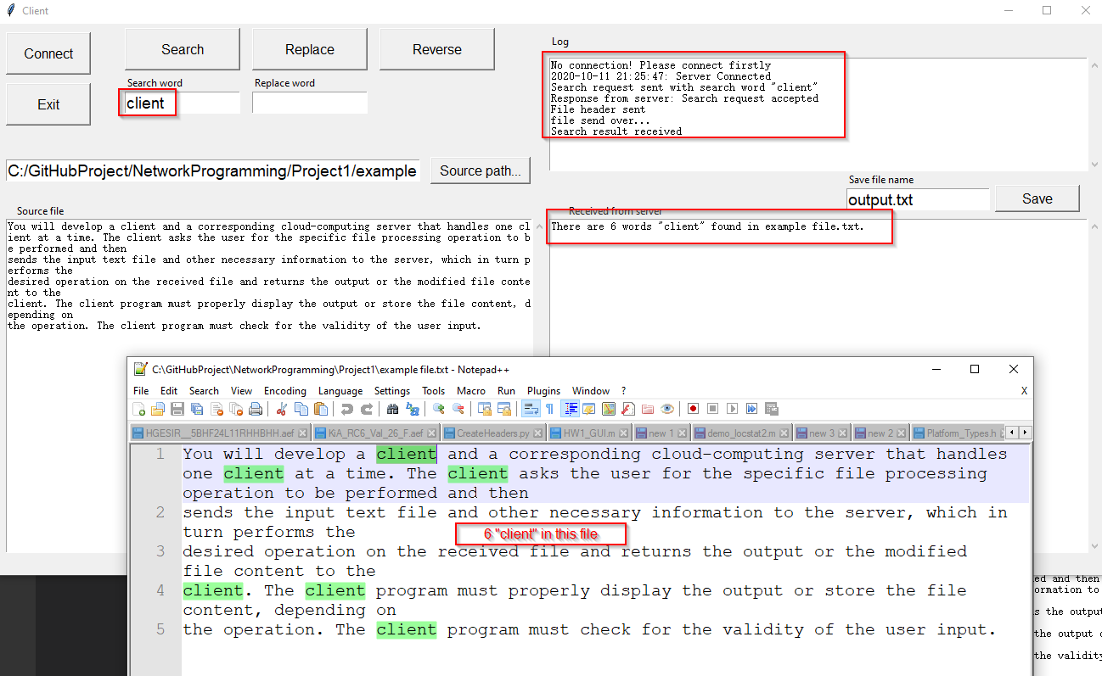

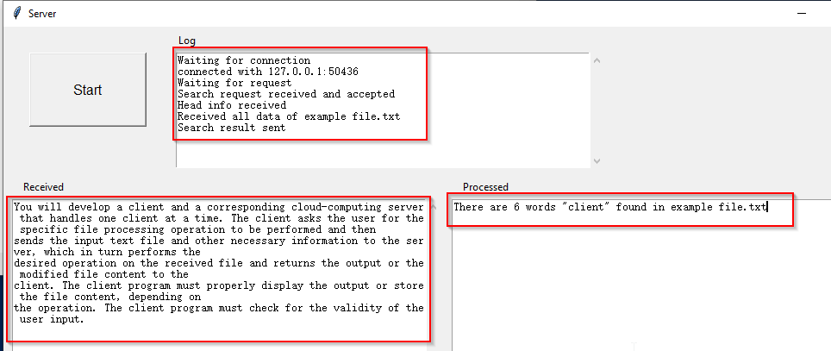

* + From above figure, the word “client” is sent to server and server accepted the request. And server sent “There are 6 words “client” found in example file.txt.
  + The info in Server program matches with Client’s
  + Log info is also showing detail steps of the communication.

1. **Replace function**

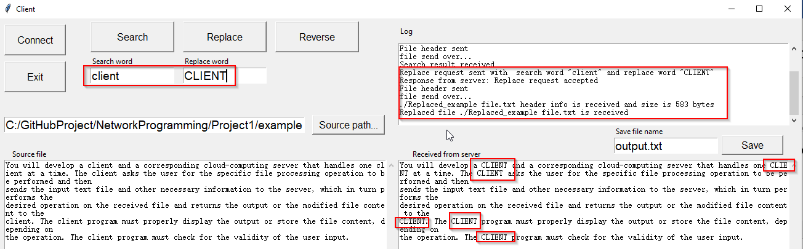

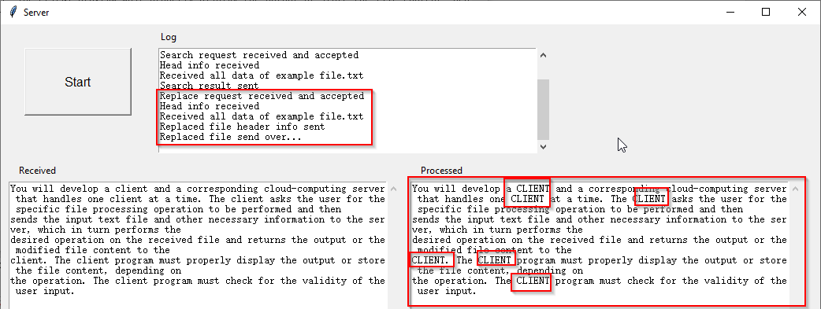

* + From the above figure, the word “client’ is replaced by “CLIENT”. The replaced file is received from server and showed in client program.
  + The info in Server program matches with Client’s
  + Log info is also showing detail steps of the communication.

1. **Reverse function**

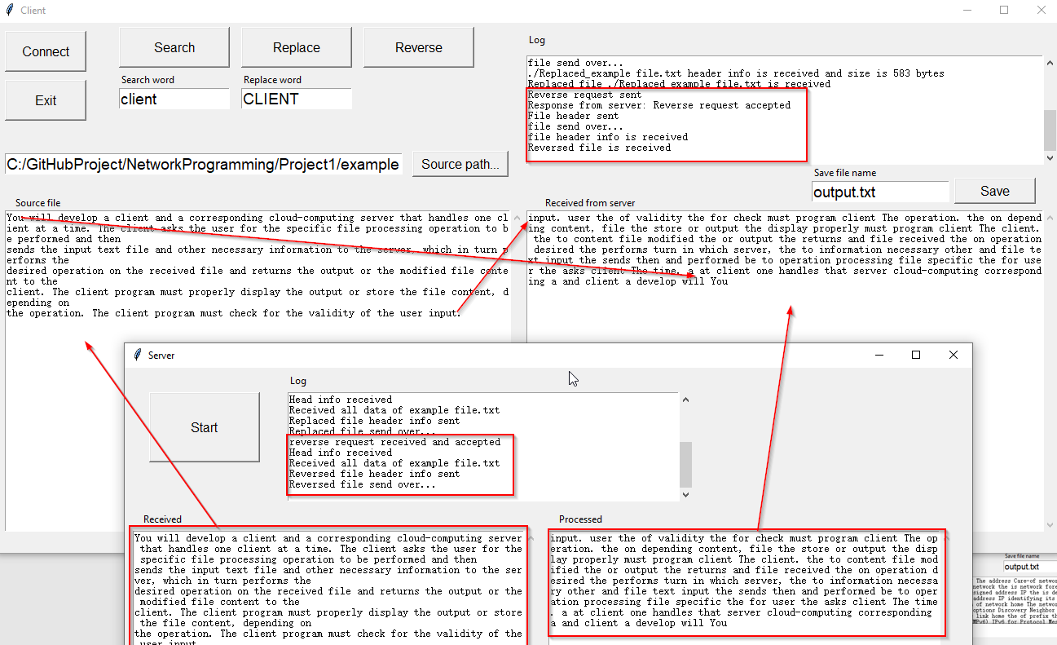

* + Server received the source file sent from client. From the content showing above , it is same as the source file.
  + Client received the reversed file sent from Server. From the content showing above, it is same as the processed content in server.
  + Log info is also showing detail steps of the communication.

1. **Save file**

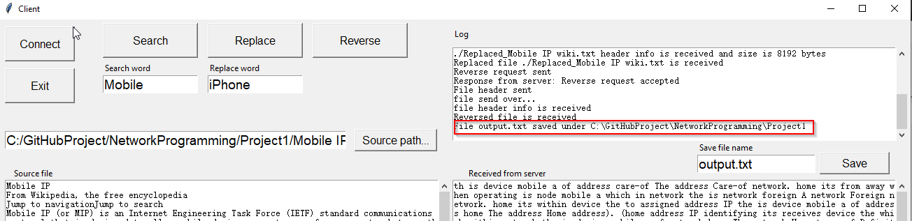

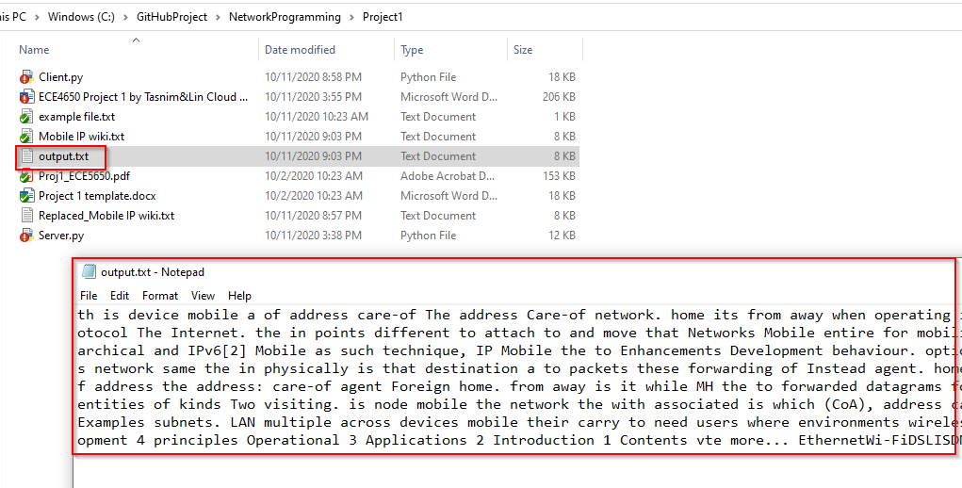

1. **Exit function**
2. **Robust test**
   1. Server not started case

When server is not started, Click on “Connect” button, “Server Connected failed” is reported.

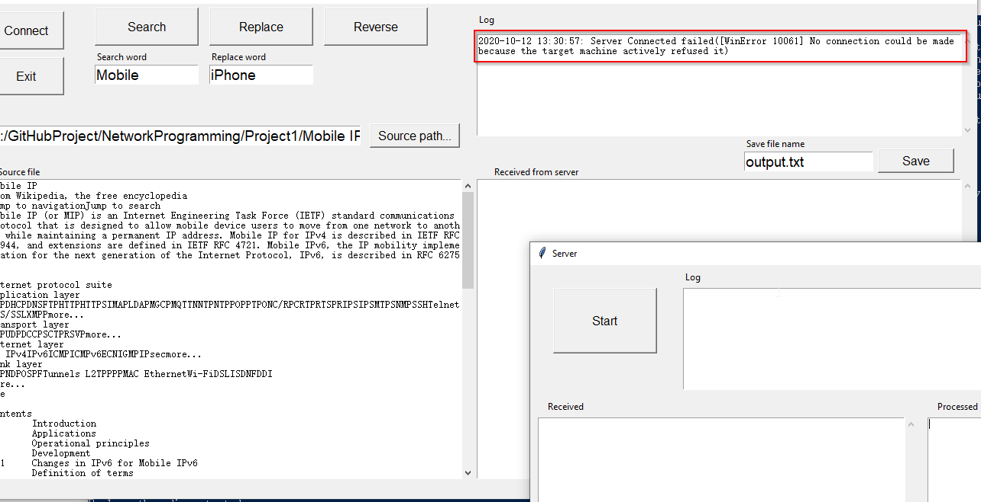

* 1. Client closed without clicking “Exit” button

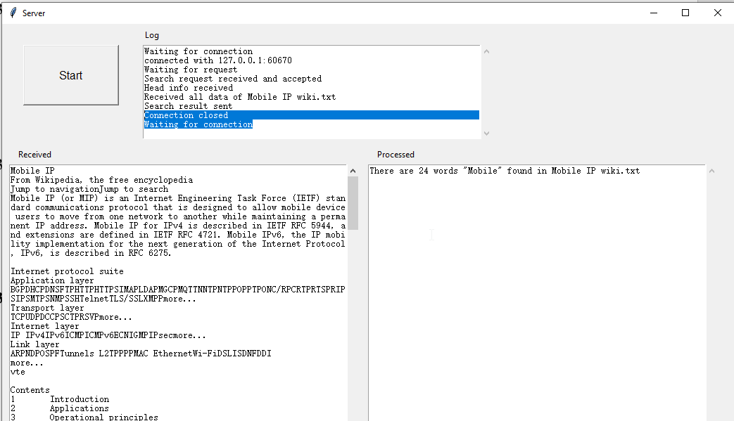

* 1. Server shutdown after connected with Client

After replace request, the client program report “Server Connected failed”

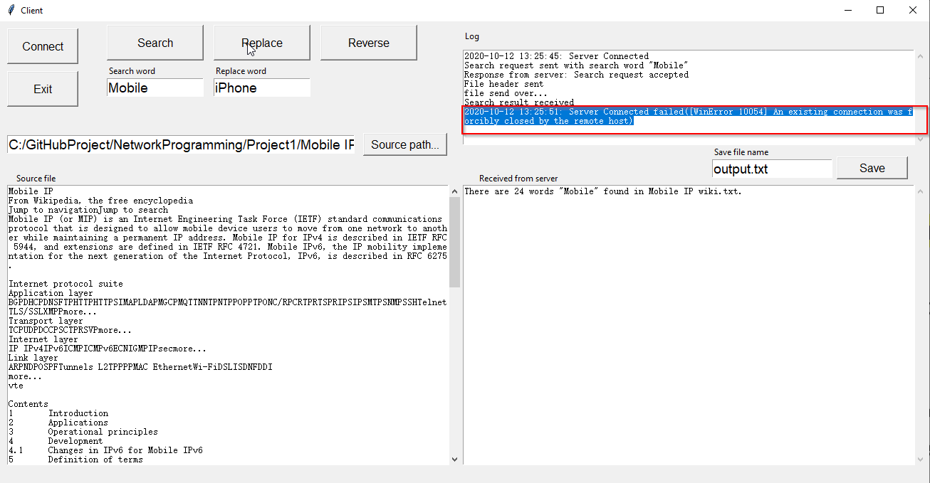

**Completion Status and Self-Critique:**

For program **Client.py**:

* Does your program meet all requirements? If not, explain the problem.

Yes

* Does the program run correctly all the time? If not, explain the problem.

Yes

* Did you adequately test the program? If not, specify.

Yes

* Is the program well documented?

Yes

For program **Server.py**:

* Does your program meet all requirements? If not, explain the problem.

Yes

* Does the program run correctly all the time? If not, explain the problem.

Yes

* Did you adequately test the program? If not, specify.

Yes

* Is the program well documented?

Yes